**Capstone Project: Battle of the Neighborhoods**

**Introduction**

The City of New York, usually called either New York City (NYC) or simply New York (NY), is the most populous city in the United States. With an estimated 2018 population of 8,398,748 distributed over a land area of about 302.6 square miles (784 km2), New York is also the most densely populated major city in the United States.[10] Located at the southern tip of the state of New York, the city is the center of the New York metropolitan area, the largest metropolitan area in the world by urban landmass[11] and one of the world's most populous megacities,[12][13] with an estimated 19,979,477 people in its 2018 Metropolitan Statistical Area and 22,679,948 residents in its Combined Statistical Area

Throughout its history, New York City has been a major point of entry for immigrants; the term "melting pot" was coined to describe densely populated immigrant neighborhoods on the Lower East Side. As many as 800 languages are spoken in New York, making it the most linguistically diverse city in the world. English remains the most widely spoken language, although there are areas in the outer boroughs in which up to 25% of people speak English as an alternate language, and/or have limited or no English language fluency. English is least spoken in neighborhoods such as Flushing, Sunset Park, and Corona.

With its diverse culture, comes diverse food items. There are many restaurants in New York City, each belonging to different categories like Chinese, Indian, French etc. Interested to know how far consumers are willing to travel to satisfy their cravings. We call this people’s willingness to travel. Understanding the complex interaction between someone’s preference for pizza and the distance he/she willing to travel to get it can help retailers develop a nuanced understanding of a local population’s food preferences

So as part of this project, we will list and visualize all major parts of New York City that has great Indian restaurants.

**Data**

For this project we need the following data:

New York City data that contains list Boroughs, Neighborhoods along with their latitude and longitude.

Data source: **https://cocl.us/new_york_dataset**

Description: This data set contains the required information. And we will use this data set to explore various neighborhoods of New York city. Indian restaurants in each neighborhood of New York city.

Data source: Four square API

Description: By using this API we will get all the venues in each neighborhood. We can filter these venues to get only Indian Restaurants.

**Geo Space data**

Data source: https://data.cityofnewyork.us/City-Government/Borough-Boundaries/tqmj-j8zm

Description: By using this geo space data we will get the New York Borough boundaries that will help us visualize choropleth map.

**Analysis Approach**

* Collect New York City Data from <https://cocl.us/new_york_dataset>
* Use Four Square Data API to find all venues for each Neighborhood
* Since Indian Restaurants are our interest, filter those venues out
* Using Four Square APIs, find ratings, tips and like counts for every Indian Restaurants in NYC
* Sort data for each Indian restaurant
* Visualize ranking of each neighborhood using Folium library

**Answer the following Questions using above listed datasets**

* What is the best location to start an Indian Restaurant in New York City?
* What are the demographics & locations of existing Indian Restaurants in New York City?
* Are highly rated Indian restaurants located in a specific location?
* Which areas of New York City lack Indian Restaurants?

**Results:**

1. Queens in New York has the highest number of Neighborhoods and Indian Restaurants

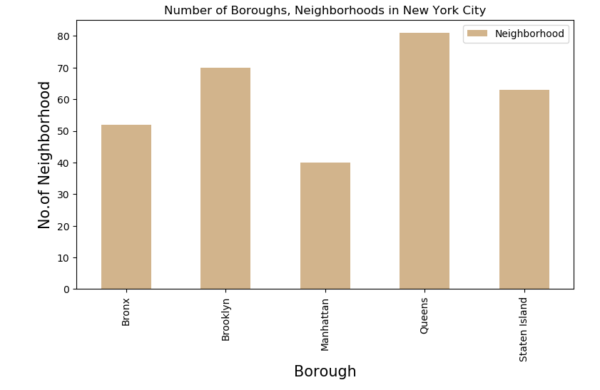

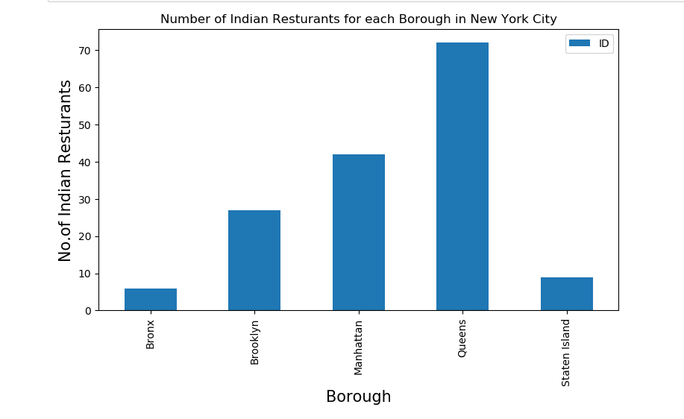

1. Floral Park Neighborhood has the highest number of Indian Restaurants

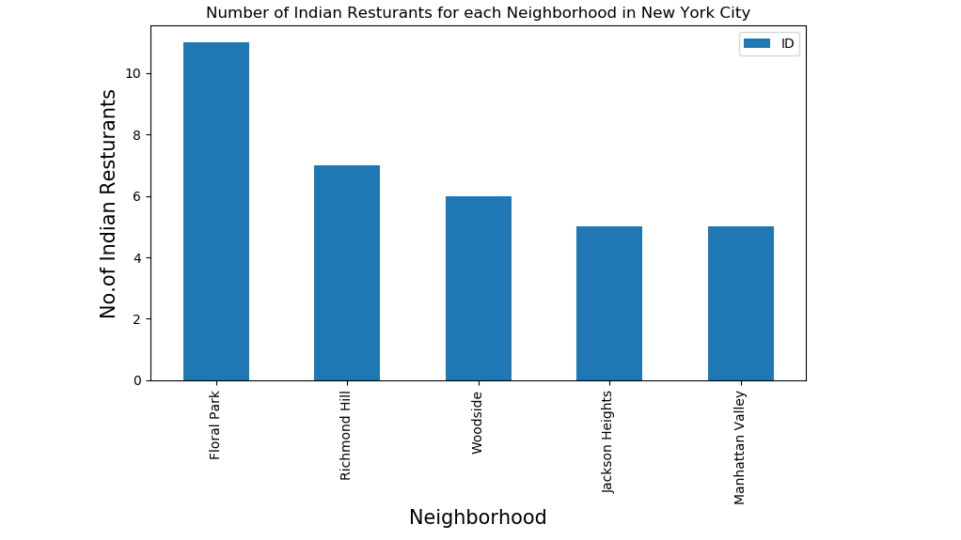

1. Tribeca Neighborhood has the highest Average Rating of 9.0 for Indian Restaurants.

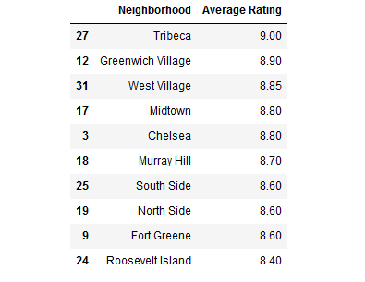

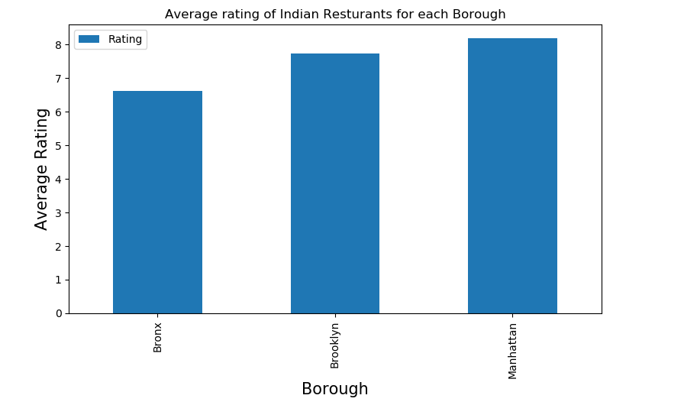

1. Map based on Average Rating of Indian Restaurants in New York

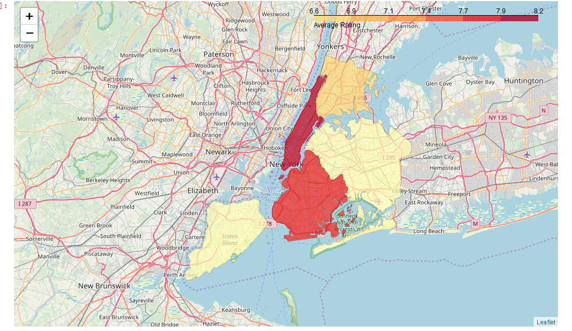

**Conclusion**

* Astoria (Queens), Bliss Ville (Queens), Civic Center (Manhattan) are some of the best neighborhoods for Indian cuisine.
* Indian Business Owners looking for a place to open restaurant business with Indian Cuisine, Manhattan has the potential for Indian Restaurant Market.
* Staten Island ranks last in average rating of Indian Restaurants. If you prefer Indian Cuisine, Manhattan is the place to be in.
* The location details and ratings are UpToDate as per the norms provided by Four Square places API

**Limitations**

The ranking is purely on basis of rating of restaurants provided by API

The accuracy of data depends purely depends on the data provided by FourSquare API